**Математика 6 – Б клас**

1. На урок **№ 67** П. 29 – 33 вивчити правила

Завдання 922, 923, 925, 926

1. На урок **№ 68 п.** 29-33 повторити правила

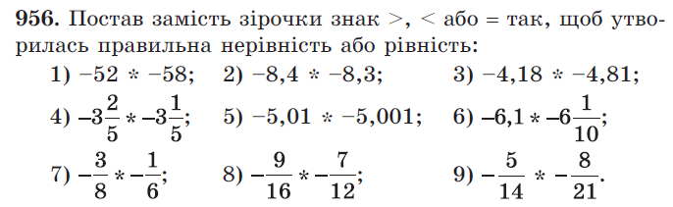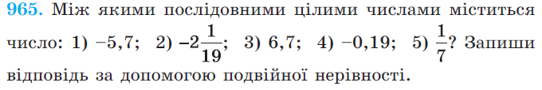

1. На урок **№ 69**

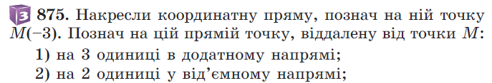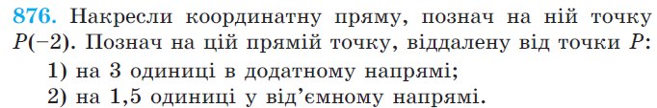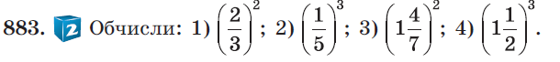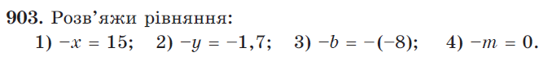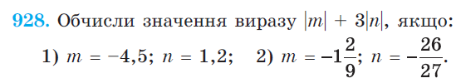

1. На урок **№ 70** Контрольна робота № 7 (виконати 1 варіант за власним вибором у зошиті для робіт)

Контрольна робота № 7

з математики

уч ___________6 - ____ класу

________________________________________________________________________________________________________________________________

Варіант 3

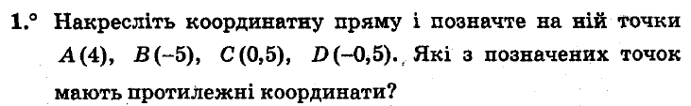

|  |  |  |  |  |  |  |  |  |  |  |  |  |  |  |  |  |  |  |  |  |  |  |  |  |  |  |  |
| --- | --- | --- | --- | --- | --- | --- | --- | --- | --- | --- | --- | --- | --- | --- | --- | --- | --- | --- | --- | --- | --- | --- | --- | --- | --- | --- | --- |
|  |  |  |  |  |  |  |  |  |  |  |  |  |  |  |  |  |  |  |  |  |  |  |  |  |  |  |  |
|  |  |  |  |  |  |  |  |  |  |  |  |  |  |  |  |  |  |  |  |  |  |  |  |  |  |  |  |
|  |  |  |  |  |  |  |  |  |  |  |  |  |  |  |  |  |  |  |  |  |  |  |  |  |  |  |  |
|  |  |  |  |  |  |  |  |  |  |  |  |  |  |  |  |  |  |  |  |  |  |  |  |  |  |  |  |
|  |  |  |  |  |  |  |  |  |  |  |  |  |  |  |  |  |  |  |  |  |  |  |  |  |  |  |  |
|  |  |  |  |  |  |  |  |  |  |  |  |  |  |  |  |  |  |  |  |  |  |  |  |  |  |  |  |
|  |  |  |  |  |  |  |  |  |  |  |  |  |  |  |  |  |  |  |  |  |  |  |  |  |  |  |  |

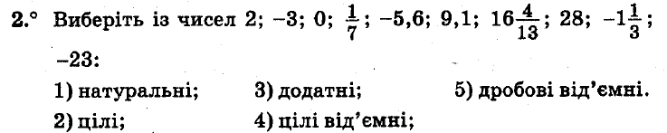

|  |  |  |  |  |  |  |  |  |  |  |  |  |  |  |  |  |  |  |  |  |  |  |  |  |  |  |  |
| --- | --- | --- | --- | --- | --- | --- | --- | --- | --- | --- | --- | --- | --- | --- | --- | --- | --- | --- | --- | --- | --- | --- | --- | --- | --- | --- | --- |
|  |  |  |  |  |  |  |  |  |  |  |  |  |  |  |  |  |  |  |  |  |  |  |  |  |  |  |  |
|  |  |  |  |  |  |  |  |  |  |  |  |  |  |  |  |  |  |  |  |  |  |  |  |  |  |  |  |
|  |  |  |  |  |  |  |  |  |  |  |  |  |  |  |  |  |  |  |  |  |  |  |  |  |  |  |  |
|  |  |  |  |  |  |  |  |  |  |  |  |  |  |  |  |  |  |  |  |  |  |  |  |  |  |  |  |
|  |  |  |  |  |  |  |  |  |  |  |  |  |  |  |  |  |  |  |  |  |  |  |  |  |  |  |  |
|  |  |  |  |  |  |  |  |  |  |  |  |  |  |  |  |  |  |  |  |  |  |  |  |  |  |  |  |
|  |  |  |  |  |  |  |  |  |  |  |  |  |  |  |  |  |  |  |  |  |  |  |  |  |  |  |  |
|  |  |  |  |  |  |  |  |  |  |  |  |  |  |  |  |  |  |  |  |  |  |  |  |  |  |  |  |
|  |  |  |  |  |  |  |  |  |  |  |  |  |  |  |  |  |  |  |  |  |  |  |  |  |  |  |  |
|  |  |  |  |  |  |  |  |  |  |  |  |  |  |  |  |  |  |  |  |  |  |  |  |  |  |  |  |
|  |  |  |  |  |  |  |  |  |  |  |  |  |  |  |  |  |  |  |  |  |  |  |  |  |  |  |  |
|  |  |  |  |  |  |  |  |  |  |  |  |  |  |  |  |  |  |  |  |  |  |  |  |  |  |  |  |
|  |  |  |  |  |  |  |  |  |  |  |  |  |  |  |  |  |  |  |  |  |  |  |  |  |  |  |  |
|  |  |  |  |  |  |  |  |  |  |  |  |  |  |  |  |  |  |  |  |  |  |  |  |  |  |  |  |
|  |  |  |  |  |  |  |  |  |  |  |  |  |  |  |  |  |  |  |  |  |  |  |  |  |  |  |  |

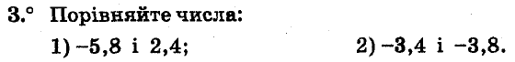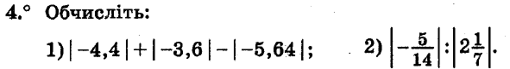

|  |  |  |  |  |  |  |  |  |  |  |  |  |  |  |  |  |  |  |  |  |  |  |  |  |  |  |  |
| --- | --- | --- | --- | --- | --- | --- | --- | --- | --- | --- | --- | --- | --- | --- | --- | --- | --- | --- | --- | --- | --- | --- | --- | --- | --- | --- | --- |
|  |  |  |  |  |  |  |  |  |  |  |  |  |  |  |  |  |  |  |  |  |  |  |  |  |  |  |  |
|  |  |  |  |  |  |  |  |  |  |  |  |  |  |  |  |  |  |  |  |  |  |  |  |  |  |  |  |
|  |  |  |  |  |  |  |  |  |  |  |  |  |  |  |  |  |  |  |  |  |  |  |  |  |  |  |  |
|  |  |  |  |  |  |  |  |  |  |  |  |  |  |  |  |  |  |  |  |  |  |  |  |  |  |  |  |
|  |  |  |  |  |  |  |  |  |  |  |  |  |  |  |  |  |  |  |  |  |  |  |  |  |  |  |  |
|  |  |  |  |  |  |  |  |  |  |  |  |  |  |  |  |  |  |  |  |  |  |  |  |  |  |  |  |
|  |  |  |  |  |  |  |  |  |  |  |  |  |  |  |  |  |  |  |  |  |  |  |  |  |  |  |  |
|  |  |  |  |  |  |  |  |  |  |  |  |  |  |  |  |  |  |  |  |  |  |  |  |  |  |  |  |
|  |  |  |  |  |  |  |  |  |  |  |  |  |  |  |  |  |  |  |  |  |  |  |  |  |  |  |  |
|  |  |  |  |  |  |  |  |  |  |  |  |  |  |  |  |  |  |  |  |  |  |  |  |  |  |  |  |
|  |  |  |  |  |  |  |  |  |  |  |  |  |  |  |  |  |  |  |  |  |  |  |  |  |  |  |  |
|  |  |  |  |  |  |  |  |  |  |  |  |  |  |  |  |  |  |  |  |  |  |  |  |  |  |  |  |

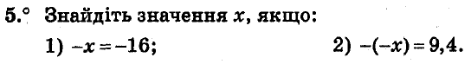

|  |  |  |  |  |  |  |  |  |  |  |  |  |  |  |  |  |  |  |  |  |  |  |  |  |  |  |  |
| --- | --- | --- | --- | --- | --- | --- | --- | --- | --- | --- | --- | --- | --- | --- | --- | --- | --- | --- | --- | --- | --- | --- | --- | --- | --- | --- | --- |
|  |  |  |  |  |  |  |  |  |  |  |  |  |  |  |  |  |  |  |  |  |  |  |  |  |  |  |  |
|  |  |  |  |  |  |  |  |  |  |  |  |  |  |  |  |  |  |  |  |  |  |  |  |  |  |  |  |
|  |  |  |  |  |  |  |  |  |  |  |  |  |  |  |  |  |  |  |  |  |  |  |  |  |  |  |  |
|  |  |  |  |  |  |  |  |  |  |  |  |  |  |  |  |  |  |  |  |  |  |  |  |  |  |  |  |
|  |  |  |  |  |  |  |  |  |  |  |  |  |  |  |  |  |  |  |  |  |  |  |  |  |  |  |  |
|  |  |  |  |  |  |  |  |  |  |  |  |  |  |  |  |  |  |  |  |  |  |  |  |  |  |  |  |
|  |  |  |  |  |  |  |  |  |  |  |  |  |  |  |  |  |  |  |  |  |  |  |  |  |  |  |  |

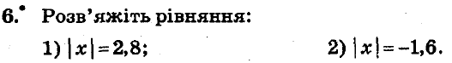

|  |  |  |  |  |  |  |  |  |  |  |  |  |  |  |  |  |  |  |  |  |  |  |  |  |  |  |  |
| --- | --- | --- | --- | --- | --- | --- | --- | --- | --- | --- | --- | --- | --- | --- | --- | --- | --- | --- | --- | --- | --- | --- | --- | --- | --- | --- | --- |
|  |  |  |  |  |  |  |  |  |  |  |  |  |  |  |  |  |  |  |  |  |  |  |  |  |  |  |  |
|  |  |  |  |  |  |  |  |  |  |  |  |  |  |  |  |  |  |  |  |  |  |  |  |  |  |  |  |
|  |  |  |  |  |  |  |  |  |  |  |  |  |  |  |  |  |  |  |  |  |  |  |  |  |  |  |  |
|  |  |  |  |  |  |  |  |  |  |  |  |  |  |  |  |  |  |  |  |  |  |  |  |  |  |  |  |
|  |  |  |  |  |  |  |  |  |  |  |  |  |  |  |  |  |  |  |  |  |  |  |  |  |  |  |  |
|  |  |  |  |  |  |  |  |  |  |  |  |  |  |  |  |  |  |  |  |  |  |  |  |  |  |  |  |
|  |  |  |  |  |  |  |  |  |  |  |  |  |  |  |  |  |  |  |  |  |  |  |  |  |  |  |  |



|  |  |  |  |  |  |  |  |  |  |  |  |  |  |  |  |  |  |  |  |  |  |  |  |  |  |  |  |
| --- | --- | --- | --- | --- | --- | --- | --- | --- | --- | --- | --- | --- | --- | --- | --- | --- | --- | --- | --- | --- | --- | --- | --- | --- | --- | --- | --- |
|  |  |  |  |  |  |  |  |  |  |  |  |  |  |  |  |  |  |  |  |  |  |  |  |  |  |  |  |
|  |  |  |  |  |  |  |  |  |  |  |  |  |  |  |  |  |  |  |  |  |  |  |  |  |  |  |  |
|  |  |  |  |  |  |  |  |  |  |  |  |  |  |  |  |  |  |  |  |  |  |  |  |  |  |  |  |
|  |  |  |  |  |  |  |  |  |  |  |  |  |  |  |  |  |  |  |  |  |  |  |  |  |  |  |  |
|  |  |  |  |  |  |  |  |  |  |  |  |  |  |  |  |  |  |  |  |  |  |  |  |  |  |  |  |
|  |  |  |  |  |  |  |  |  |  |  |  |  |  |  |  |  |  |  |  |  |  |  |  |  |  |  |  |
|  |  |  |  |  |  |  |  |  |  |  |  |  |  |  |  |  |  |  |  |  |  |  |  |  |  |  |  |

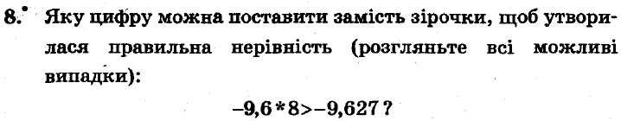

|  |  |  |  |  |  |  |  |  |  |  |  |  |  |  |  |  |  |  |  |  |  |  |  |  |  |  |  |
| --- | --- | --- | --- | --- | --- | --- | --- | --- | --- | --- | --- | --- | --- | --- | --- | --- | --- | --- | --- | --- | --- | --- | --- | --- | --- | --- | --- |
|  |  |  |  |  |  |  |  |  |  |  |  |  |  |  |  |  |  |  |  |  |  |  |  |  |  |  |  |
|  |  |  |  |  |  |  |  |  |  |  |  |  |  |  |  |  |  |  |  |  |  |  |  |  |  |  |  |
|  |  |  |  |  |  |  |  |  |  |  |  |  |  |  |  |  |  |  |  |  |  |  |  |  |  |  |  |
|  |  |  |  |  |  |  |  |  |  |  |  |  |  |  |  |  |  |  |  |  |  |  |  |  |  |  |  |
|  |  |  |  |  |  |  |  |  |  |  |  |  |  |  |  |  |  |  |  |  |  |  |  |  |  |  |  |
|  |  |  |  |  |  |  |  |  |  |  |  |  |  |  |  |  |  |  |  |  |  |  |  |  |  |  |  |
|  |  |  |  |  |  |  |  |  |  |  |  |  |  |  |  |  |  |  |  |  |  |  |  |  |  |  |  |

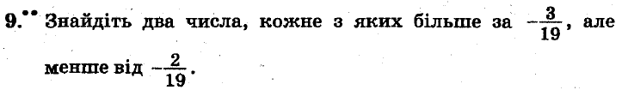

|  |  |  |  |  |  |  |  |  |  |  |  |  |  |  |  |  |  |  |  |  |  |  |  |  |  |  |  |
| --- | --- | --- | --- | --- | --- | --- | --- | --- | --- | --- | --- | --- | --- | --- | --- | --- | --- | --- | --- | --- | --- | --- | --- | --- | --- | --- | --- |
|  |  |  |  |  |  |  |  |  |  |  |  |  |  |  |  |  |  |  |  |  |  |  |  |  |  |  |  |
|  |  |  |  |  |  |  |  |  |  |  |  |  |  |  |  |  |  |  |  |  |  |  |  |  |  |  |  |
|  |  |  |  |  |  |  |  |  |  |  |  |  |  |  |  |  |  |  |  |  |  |  |  |  |  |  |  |
|  |  |  |  |  |  |  |  |  |  |  |  |  |  |  |  |  |  |  |  |  |  |  |  |  |  |  |  |
|  |  |  |  |  |  |  |  |  |  |  |  |  |  |  |  |  |  |  |  |  |  |  |  |  |  |  |  |
|  |  |  |  |  |  |  |  |  |  |  |  |  |  |  |  |  |  |  |  |  |  |  |  |  |  |  |  |
|  |  |  |  |  |  |  |  |  |  |  |  |  |  |  |  |  |  |  |  |  |  |  |  |  |  |  |  |
|  |  |  |  |  |  |  |  |  |  |  |  |  |  |  |  |  |  |  |  |  |  |  |  |  |  |  |  |
|  |  |  |  |  |  |  |  |  |  |  |  |  |  |  |  |  |  |  |  |  |  |  |  |  |  |  |  |
|  |  |  |  |  |  |  |  |  |  |  |  |  |  |  |  |  |  |  |  |  |  |  |  |  |  |  |  |
|  |  |  |  |  |  |  |  |  |  |  |  |  |  |  |  |  |  |  |  |  |  |  |  |  |  |  |  |
|  |  |  |  |  |  |  |  |  |  |  |  |  |  |  |  |  |  |  |  |  |  |  |  |  |  |  |  |
|  |  |  |  |  |  |  |  |  |  |  |  |  |  |  |  |  |  |  |  |  |  |  |  |  |  |  |  |
|  |  |  |  |  |  |  |  |  |  |  |  |  |  |  |  |  |  |  |  |  |  |  |  |  |  |  |  |
|  |  |  |  |  |  |  |  |  |  |  |  |  |  |  |  |  |  |  |  |  |  |  |  |  |  |  |  |
|  |  |  |  |  |  |  |  |  |  |  |  |  |  |  |  |  |  |  |  |  |  |  |  |  |  |  |  |
|  |  |  |  |  |  |  |  |  |  |  |  |  |  |  |  |  |  |  |  |  |  |  |  |  |  |  |  |
|  |  |  |  |  |  |  |  |  |  |  |  |  |  |  |  |  |  |  |  |  |  |  |  |  |  |  |  |
|  |  |  |  |  |  |  |  |  |  |  |  |  |  |  |  |  |  |  |  |  |  |  |  |  |  |  |  |
|  |  |  |  |  |  |  |  |  |  |  |  |  |  |  |  |  |  |  |  |  |  |  |  |  |  |  |  |
|  |  |  |  |  |  |  |  |  |  |  |  |  |  |  |  |  |  |  |  |  |  |  |  |  |  |  |  |
|  |  |  |  |  |  |  |  |  |  |  |  |  |  |  |  |  |  |  |  |  |  |  |  |  |  |  |  |
|  |  |  |  |  |  |  |  |  |  |  |  |  |  |  |  |  |  |  |  |  |  |  |  |  |  |  |  |
|  |  |  |  |  |  |  |  |  |  |  |  |  |  |  |  |  |  |  |  |  |  |  |  |  |  |  |  |
|  |  |  |  |  |  |  |  |  |  |  |  |  |  |  |  |  |  |  |  |  |  |  |  |  |  |  |  |
|  |  |  |  |  |  |  |  |  |  |  |  |  |  |  |  |  |  |  |  |  |  |  |  |  |  |  |  |
|  |  |  |  |  |  |  |  |  |  |  |  |  |  |  |  |  |  |  |  |  |  |  |  |  |  |  |  |
|  |  |  |  |  |  |  |  |  |  |  |  |  |  |  |  |  |  |  |  |  |  |  |  |  |  |  |  |
|  |  |  |  |  |  |  |  |  |  |  |  |  |  |  |  |  |  |  |  |  |  |  |  |  |  |  |  |
|  |  |  |  |  |  |  |  |  |  |  |  |  |  |  |  |  |  |  |  |  |  |  |  |  |  |  |  |

Контрольна робота № 7

з математики

уч ___________6 - ____ класу

________________________________________________________________________________________________________________________________

Варіант 4

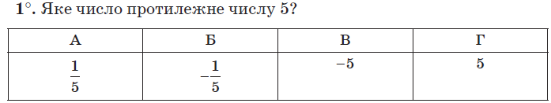 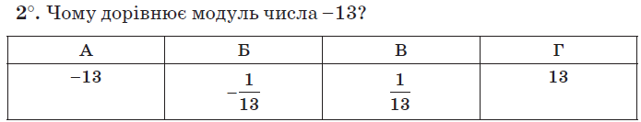 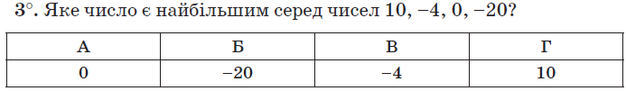 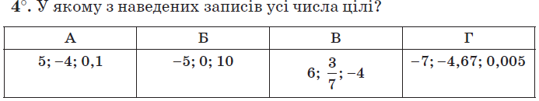 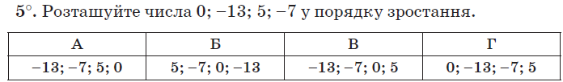 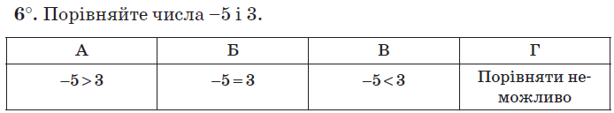

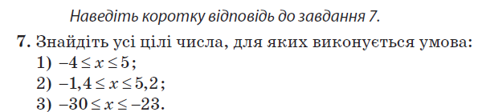

|  |  |  |  |  |  |  |  |  |  |  |  |  |  |  |  |  |  |  |  |  |  |  |  |  |  |  |  |
| --- | --- | --- | --- | --- | --- | --- | --- | --- | --- | --- | --- | --- | --- | --- | --- | --- | --- | --- | --- | --- | --- | --- | --- | --- | --- | --- | --- |
|  |  |  |  |  |  |  |  |  |  |  |  |  |  |  |  |  |  |  |  |  |  |  |  |  |  |  |  |
|  |  |  |  |  |  |  |  |  |  |  |  |  |  |  |  |  |  |  |  |  |  |  |  |  |  |  |  |
|  |  |  |  |  |  |  |  |  |  |  |  |  |  |  |  |  |  |  |  |  |  |  |  |  |  |  |  |
|  |  |  |  |  |  |  |  |  |  |  |  |  |  |  |  |  |  |  |  |  |  |  |  |  |  |  |  |
|  |  |  |  |  |  |  |  |  |  |  |  |  |  |  |  |  |  |  |  |  |  |  |  |  |  |  |  |
|  |  |  |  |  |  |  |  |  |  |  |  |  |  |  |  |  |  |  |  |  |  |  |  |  |  |  |  |
|  |  |  |  |  |  |  |  |  |  |  |  |  |  |  |  |  |  |  |  |  |  |  |  |  |  |  |  |

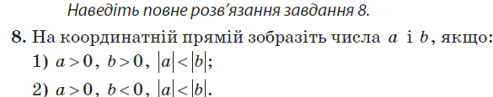

|  |  |  |  |  |  |  |  |  |  |  |  |  |  |  |  |  |  |  |  |  |  |  |  |  |  |  |  |
| --- | --- | --- | --- | --- | --- | --- | --- | --- | --- | --- | --- | --- | --- | --- | --- | --- | --- | --- | --- | --- | --- | --- | --- | --- | --- | --- | --- |
|  |  |  |  |  |  |  |  |  |  |  |  |  |  |  |  |  |  |  |  |  |  |  |  |  |  |  |  |
|  |  |  |  |  |  |  |  |  |  |  |  |  |  |  |  |  |  |  |  |  |  |  |  |  |  |  |  |
|  |  |  |  |  |  |  |  |  |  |  |  |  |  |  |  |  |  |  |  |  |  |  |  |  |  |  |  |
|  |  |  |  |  |  |  |  |  |  |  |  |  |  |  |  |  |  |  |  |  |  |  |  |  |  |  |  |
|  |  |  |  |  |  |  |  |  |  |  |  |  |  |  |  |  |  |  |  |  |  |  |  |  |  |  |  |
|  |  |  |  |  |  |  |  |  |  |  |  |  |  |  |  |  |  |  |  |  |  |  |  |  |  |  |  |
|  |  |  |  |  |  |  |  |  |  |  |  |  |  |  |  |  |  |  |  |  |  |  |  |  |  |  |  |

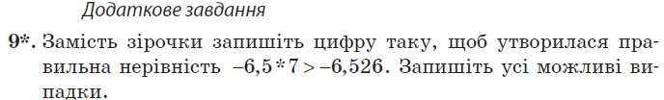

|  |  |  |  |  |  |  |  |  |  |  |  |  |  |  |  |  |  |  |  |  |  |  |  |  |  |  |  |
| --- | --- | --- | --- | --- | --- | --- | --- | --- | --- | --- | --- | --- | --- | --- | --- | --- | --- | --- | --- | --- | --- | --- | --- | --- | --- | --- | --- |
|  |  |  |  |  |  |  |  |  |  |  |  |  |  |  |  |  |  |  |  |  |  |  |  |  |  |  |  |
|  |  |  |  |  |  |  |  |  |  |  |  |  |  |  |  |  |  |  |  |  |  |  |  |  |  |  |  |
|  |  |  |  |  |  |  |  |  |  |  |  |  |  |  |  |  |  |  |  |  |  |  |  |  |  |  |  |
|  |  |  |  |  |  |  |  |  |  |  |  |  |  |  |  |  |  |  |  |  |  |  |  |  |  |  |  |
|  |  |  |  |  |  |  |  |  |  |  |  |  |  |  |  |  |  |  |  |  |  |  |  |  |  |  |  |
|  |  |  |  |  |  |  |  |  |  |  |  |  |  |  |  |  |  |  |  |  |  |  |  |  |  |  |  |
|  |  |  |  |  |  |  |  |  |  |  |  |  |  |  |  |  |  |  |  |  |  |  |  |  |  |  |  |

Контрольна робота № 7

з математики

уч ___________6 - ____ класу

________________________________________________________________________________________________________________________________

Варіант 5



                                                        
                                                        
                                                        
                                                        
                                                        
                                                        
                                                        
                                                        
                                                        